

Agency Full Name (XXX)
IT Security Assessment for XXX Application
Draft Report
November 2025
Confidential
Confidentiality Statement
Our audit reports are intended solely for the information and use of management and the Board of Directors of Agency Full Name(“XXX”) and should not be used for any other purpose. XXX may not provide access to or copies of this report to any third-party without the prior written consent of VibeDocs Assurance Singapore Pte. Ltd. (“VibeDocs”).
Disclaimer
For the avoidance of doubt, the services provided are advisory in nature and have not been conducted in accordance with any accounting standards and consequently, no opinions or conclusions under these standards are expressed.
There are inherent limitations in any auditing and review process. Because of the characteristics of fraud (including computer fraud), particularly those involving concealment, misrepresentation, and falsified documentation (including forgery), a properly planned and performed audit may not detect fraud.
In addition, an audit does not necessarily address the possibility that fraud may occur in the future. We have completed our review with our procedures being designed to meet the objectives as outlined in our terms of reference. These procedures were not designed to detect fraud and accordingly, no assurance can or should be taken as to the non-existence of any fraud that may exist.
Furthermore, there are inherent weaknesses of any internal controls system. These include management over-ride of controls, cost-benefit considerations, and the possibility of employee collusion. Internal controls systems will always be potentially subject to these weaknesses.
It is further noted that this was a point in time test and security testing was limited to the agreed upon hours. With further time and testing, it is possible that additional observations may be identified.
We believe that the statements made in this report are accurate, but no warranty of completeness, accuracy, or reliability is given in relations to the statements and representations made by and the information and documentation provided by XXX personnel. We have not attempted to verify these sources independently unless otherwise noted within the report.
VibeDocs recommends XXX perform additional rounds of vulnerability assessment/penetration testing on its systems periodically or whenever significant changes are made. Significant changes, such as new software versions or the installation of new devices, may result in new vulnerabilities arising.

General Information
Client Name | Agency Full Name
Project Name | IT Security Assessment for XXX Application

Document Information
Document Type: | Draft Report
Document File Name: | Security Assessment XXX CPT Draft Report v0.1 (Template) .docx
Document Version: | 0.1
Version Date: | November 2025

Document Change History
Version Date | Version No. | Description of Changes | Revised By
 | 0.1 | Initial draft report

Distribution List
Name and Title | Role In Engagement | Purpose
 | Agency POC | Reviewer
 | Agency POC | Reviewer
 | VibeDocs Engagement Partner | Reviewer
 | VibeDocs Engagement Director | Reviewer
 | VibeDocs Team Member | Author

Table of Contents
1.0 Executive Summary 1-4
1.1 Follow-up Verification 1-5
1.2 Risk Register 1-5
2.0 Introduction 2-1
2.1 Vulnerability Scanning Tools Used 2-1
2.2 Testing Scope 2-1
2.2.1 Cloud Vulnerability Assessment and Penetration Testing 2-1
2.3 Testing Coverage 2-2
2.4 Methodology & Approach 2-3
2.5 Timeline 2-4
2.6 Risk Model 2-5
2.6.1 CVSS Version 4.0 Risk Rating 2-5
2.6.2 Risk Resolution Timeline 2-6
3.0 Detailed Findings – Cloud Vulnerability Assessment 3-1
3.1 Filtering Criteria for Unauthorised Access Attempts Not Configured in Cloud Trail Metrics 3-1
4.0 Detailed Findings – Cloud Penetration Testing 4-3
4.1 Excessive Permissions Leading to Privilege Escalation via Lambda and IAM Misconfiguration 4-3
5.0 Annex A: Cloud Vulnerability Assessment 5-9

Table of Tables
Table 1-1: Summary of Findings based on CVSS version 4.0 as of xx 1-4
Table 2-1: Overview of Security Testing Schedule 2-4
Table 2-2: CVSS Severity Ratings 2-5
Table 2-3: Risk Resolution Timeline 2-6

Table of Figures
Figure 3.1-2 Log filter pattern configured 3-2

Executive Summary
Deloitte & Touche Enterprise Risk Services Pte Ltd (“VibeDocs”) has been engaged by the Agency Full Name(“XXX”) to perform an IT Security Assessment for XXX Application (“XXX”)
The objective of this assessment is to identify, and demonstrate possible exploits, application vulnerabilities in the system, gather the system evidence for each finding, assess the risk level and potential implications of each threat and propose corresponding recommendations for remediation.
The scope of the testing covers Cloud Vulnerability Assessment and Penetration Testing. Refer to Section 2.1 for detailed Assessment Scope.
The review on IT Security Assessment for XXX Application was conducted from XXX November 2024 – XXX November 2024.
During the course of the assessment, a total of 2 findings have been identified. There were 1 high risk and 1 medium risk issues raised from the security review. Each finding uses CVSS version 4.0 Risk Rating standard. Refer to Table 1-1 below for the issue breakdown.

Review Areas |  |  |  | Risk Level
 | Critical |  | High |  | Medium | Low | Info | Total
XXX
Cloud Vulnerability Assessment | - |  | - |  | 1 | - | - | 1
Cloud Penetration Testing | - |  | 1 |  | - | - | - | 1
Total | - |  | 1 |  | 1 | - | - | 1
Table 1-1: Summary of Findings based on CVSS version 4.0 as of xx
The issues discovered during the assessment were due to security misconfigurations. These flaws often provide attackers with opportunity to unauthorized access to system data or functionality, which may result in system compromise.

Follow-up Verification
Upon the deployment of the fixes, follow up testing was conducted on xxx to xxx to determine if the remediation steps were sufficient in mitigating against the findings’ raised.
Refer to Risk Register in the next section for more details.

Risk Register
Ref. | Risk | CVSS Score | Description | Status
Cloud Vulnerability Assessment
XXX
3.1 | Medium |  | Filtering Criteria for Unauthorised Access Attempts Not Configured in Cloud Trail Metrics | Open
Cloud Penetration Testing
XXX
4.1 | High | 7.7 | Excessive Permissions Leading to Privilege Escalation via Lambda and IAM Misconfiguration | Open

Introduction
VibeDocs & Touche Enterprise Risk Services Pte Ltd (“VibeDocs”) has been engaged by the Agency Full Name (“XXX”) to conduct an IT Security Assessment for XXX Application (“XXX”).
The scope of the testing covers Cloud Vulnerability Assessment and Penetration Testing. Please refer to the details below.

Vulnerability Scanning Tools Used
Name | Version | Last Update Performed

Testing Scope
The objective of the security testing is to verify whether the applications’ security controls in place are adequate and effective against prevailing and potential threats and known vulnerabilities.
The scope of the testing covers Cloud Vulnerability Assessment and Penetration Testing. Cloud Vulnerability Assessment and Penetration Testing is a set of testing conducted to assess the security controls and defenses at network perimeter and cloud infrastructure hosted on Commercial Cloud (GCC) environment with components residing in Amazon Web Services (AWS).

Cloud Vulnerability Assessment and Penetration Testing
The penetration testing and follow up was conducted on UAT environment of XXX. Refer to the table below for the reviewed website(s).
XXX @ UAT Environment
Identified Entities

AWS Account | Account ID

Testing Coverage
The Cloud Vulnerability Assessment and Penetration Testing is to ascertain the adequacy and effectiveness of controls on the governance, security, and resiliency of the Cloud computing environment and to ascertain the adequacy and effectiveness of controls on the configuration and security of servers for key systems located on-site / premise.
The scope of the assessment involves conducting an independent assessment on the Cloud solution covering the areas of:
- Network security;
- Identity and access management of the cloud resources;
- Compute and storage security;
- Logging and monitoring;
- Review the governance of cloud security across all cloud environments;
- Review the resiliency and security of AWS environment;
- Cloud Services Misconfiguration; and
- Data Protection and Data Security.
Refer to the Section 2.4. Methodology & Approach for the detail steps of testing we conducted.

Methodology & Approach
Below diagram depicted our security testing methodology

The approach for Cloud Vulnerability Assessment and Penetration Testing is described in the steps below:
- Step 1 – Configuration Baselining
  - Identify the applicable standards, policies and guidelines from security standards or hardening guidelines.
- Step 2 – Configuration Comparisons
  - Determine the compliance criteria for each standard, policy or guidelines.
  - Review sampled cloud services to validate that they are configured and hardened in accordance to the security standards and hardening guidelines.
- Step 3 – Vulnerability Exploitation
  - Analysis of vulnerabilities identified to identify the chances of exploitation and the type of payload and attack methodology.
  - Executing attack profiles, test scripts and exploit programs to perform proof of concept to demonstrate the security of the target environment.

Timeline
The security testing was conducted between the period of XX November 2024 – XX November 2024 and in phases for different applications / sites to align with respective applications’ availability, maintenance cycle, internal testing schedules and other blackout periods.

Cloud Vulnerability Assessment and Penetration Testing
XXX Fieldwork
XXX Follow Up
Table 2-1: Overview of Security Testing Schedule

Risk Model
In order to quantify the risk level, a certain Risk Model will be used. Below are the alternative Risk Ratings model discussed and used for this project.

CVSS Version 4.0 Risk Rating
All discovered vulnerabilities are rated against the CVSS v4.0 (Common Vulnerability Scoring System). CVSS is an open framework for communicating the characteristics and impact of IT vulnerabilities. The system is a quantitative model which ensures a repeatable accurate measurement, while allowing users to see the underlying vulnerability metrics that were used to calculate the final risk.

Severity | Description
Critical | Critical severity findings relate to an issue which has major risk impact to the organization either in terms of operational, reputational, or monetary. Vulnerabilities will be labelled Critical severity if they have a CVSS base score of 9.0-10.0.
High | High severity findings relate to an issue which requires immediate attention and should be given the highest priority by the business. Vulnerabilities will be labelled High severity if they have a CVSS base score of 7.0-8.9.
Medium | Medium severity findings relate to an issue which has the potential to present a serious risk to the business. Vulnerabilities will be labelled Medium severity if they have a base CVSS score of 4.0-6.9.
Low | Minor severity findings contradict security best practice and have minimal impact on the project or business. Vulnerabilities are labelled Low severity if they have a CVSS base score of 0.1-3.9.
Info | Informational findings do not pose an immediate security risk or have a significant impact on the organization. These findings provide additional information or details about the target system, but they do not require immediate attention or remediation.  * Note: The Informational severity is not part of CVSS severity levels.
Table 2-2: CVSS Severity Ratings
For more details on CVSS V4.0 ratings and description of each scoring metric, please visit ( https://www.first.org/cvss/specification-document ).
For each finding in this report, detailed metrics used can be viewed by visiting ( https://nvd.nist.gov/vuln-metrics/cvss/v4-calculator?vector=<Vector> ) and replacing the < Vector> with the CVSS Vector listed for the corresponding issue.

Risk Resolution Timeline
The recommended risk resolution timeline are as follows:
Severity | Risk Resolution Timeline
Critical | Resolved in less than 30 days (CII/SII/Internet-facing), 60 days (Others)
High | Resolved in less than 30 days (CII/SII/Internet-facing), 60 days (Others)
Medium | Resolved in less than 60 days (CII/SII/Internet-facing), 90 days (Others)
Low | Resolved in less than 60 days (CII/SII/Internet-facing), 90 days (Others)
Table 2-3: Risk Resolution Timeline

Detailed Findings – Cloud Vulnerability Assessment
This section of the report provides the detailed findings for the cloud application penetration testing conducted on XXX including quantified risk level, impact analysis and recommended practical remediation.

Filtering Criteria for Unauthorised Access Attempts Not Configured in Cloud Trail Metrics
CVSS 4.0 Risk Rating | Overall Score | CVSS Vector
Medium
Affected Resource(s)/Instance(s)
- arn:aws:cloudtrail:ap-southeast-1:275104344024:trail/prd-goventry-cis-cloudtrail
Observations
The filtering criteria are designed to identify events such as unauthorized operations or access violations to resources. The output from the command <aws logs describe-metric-filters --log-group-name "prd-goventry-cis-cloudtrail-logs"> does not contain the following:

"filterPattern": "{ ($.errorCode = *UnauthorizedOperation) || ($.errorCode =
AccessDenied*) || ($.sourceIPAddress!=delivery.logs.amazonaws.com) ||
($.eventName!=HeadBucket) }",
Implications
Without metric filters, identifying suspicious activities such as brute-force attacks and IAM policy violations becomes inefficient, increasing the risk of undetected threats. Manual log analysis is time-consuming and prone to human error.
Recommendations
It is recommended to configure these criteria in the CloudTrail metrics to flag any potential security incidents.
Management Comments
Status
Closed
Follow Up Observations
It was observed that the log filter pattern has been configured as per the recommendation. The CloudTrail metrics now monitor unauthorized access attempts effectively. Hence, the issue can now be closed.

Follow Up Screenshots
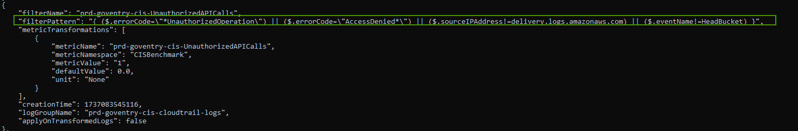
Figure 3.1-1 Log filter pattern configured

Detailed Findings – Cloud Penetration Testing
This section of the report provides the detailed findings for the cloud application penetration testing conducted on XXX including quantified risk level, impact analysis and recommended practical remediation.

Excessive Permissions Leading to Privilege Escalation via Lambda and IAM Misconfiguration
CVSS 4.0 Risk Rating | Overall Score | CVSS Vector
High | 7.7 | CVSS:4.0/AV:N/AC:L/AT:P/PR:L/UI:N/VC:H/VI:H/VA:H/SC:N/SI:N/SA:N/E:A
Observations
The “role/sgts-gitlab-runner” entity is configured with restricted permissions; however, a lack of conditional restrictions on Lambda execution permissions and insufficient resource scoping for sensitive actions, such as “iam:CreatePolicy” and “iam:AttachRolePolicy”, allowed privilege escalation. By exploiting these permissions, it was possible to create and attach a full administrator policy to a new role, which could then be assumed to bypass existing restrictions and gain elevated access. This underscores the need for stronger conditional enforcement and granular resource restrictions to mitigate risks associated with privilege escalation.
Steps to Reproduce
As referred to MITRE ATT&CK, the threat vectors might initiate an exploit using valid account, hence, the Proof-of-Concept below are based on assumed breach scenario.
- Perform “assume role” to the role “role/sgts-gitlab-runner” from the AWS SSO portal. VibeDocs has informed project team to establish trust policy so that the tester can obtain temporary token. Confirm that the assume role is successful and performing as intended.
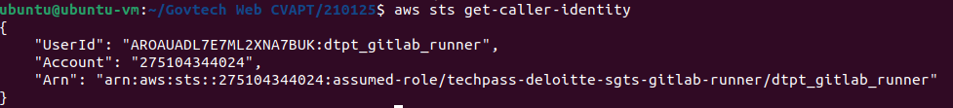
- Validate that the assumed role is performing as intended by performing known capabilities such as “ListSecrets”.
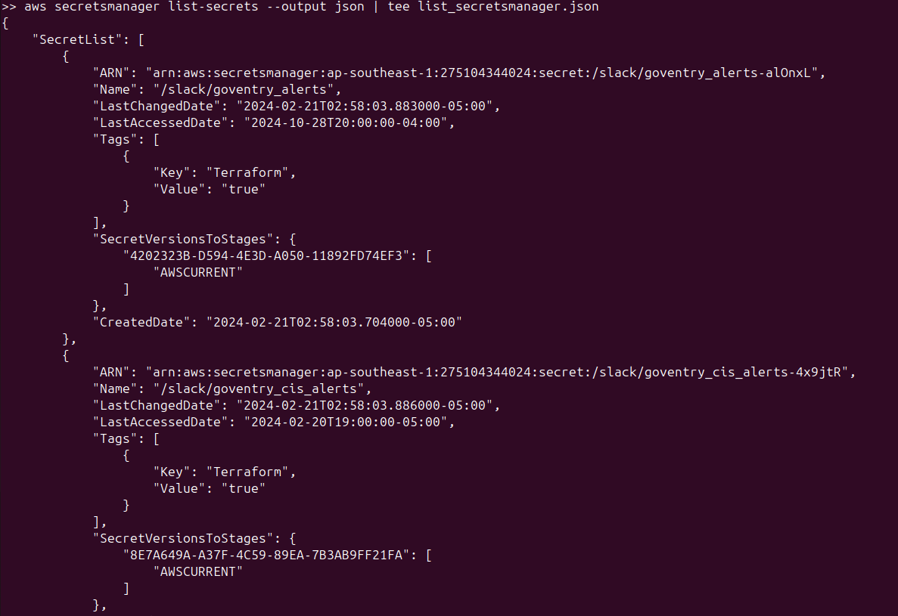
- Attempt to create unrestricted policy named “dtpt-admin-policy”. Attackers can leverage the permission of “iam:CreatePolicy*” and assign themselves with unrestricted policy. This action allows attackers to ensure less error log generated while navigating and breaching the infrastructure. The assignment of policy is eased when there is no resource-level restriction.
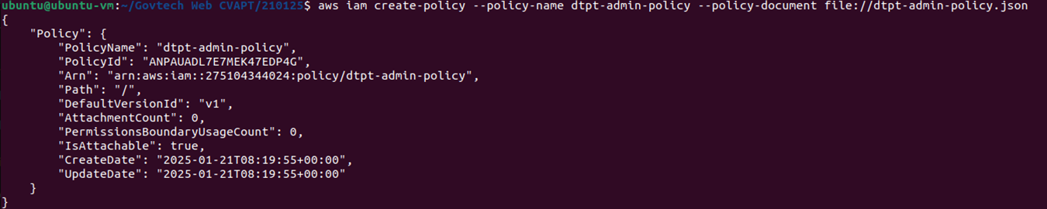
- Upon successfully creating custom admin policy, attempt to attach policy to lambda role “goventry- dbmigrate-lambda-prd”. While the “iam:AttachRolePolicy” permission is restricted to roles beginning with “goventry-*”, attackers can exploit this naming pattern to bypass restrictions and link the unrestricted policy to the intended role. This step demonstrates the risk of insufficient scoping when resource-level constraints are applied but not adequately restrictive with the use of conditions.
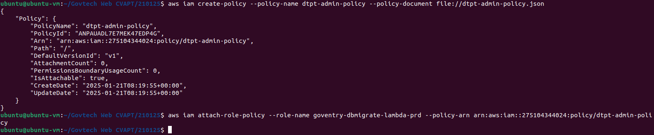
- Upon successfully attaching the policy to the target role, we attempted to update the runtime and execution time of the “goventry-dbmigrate-lambda-prd” function to Python 3.9 using the “lambda:UpdateFunctionConfiguration” permission. For the purpose of this POC, we asked GovEntry to replicate the target lambda function with a similar function as to not disrupt their cloud environment. Attackers would be able to align the Lambda function environment with their malicious payload. Although this permission is restricted to functions prefixed with “goventry-dbmigrate-lambda-prd*”, attackers can still exploit the lack of stricter conditions, such as environment validation or tagging, to make modifications which allows for unauthorized modification to prepare the function for privilege escalation activities.
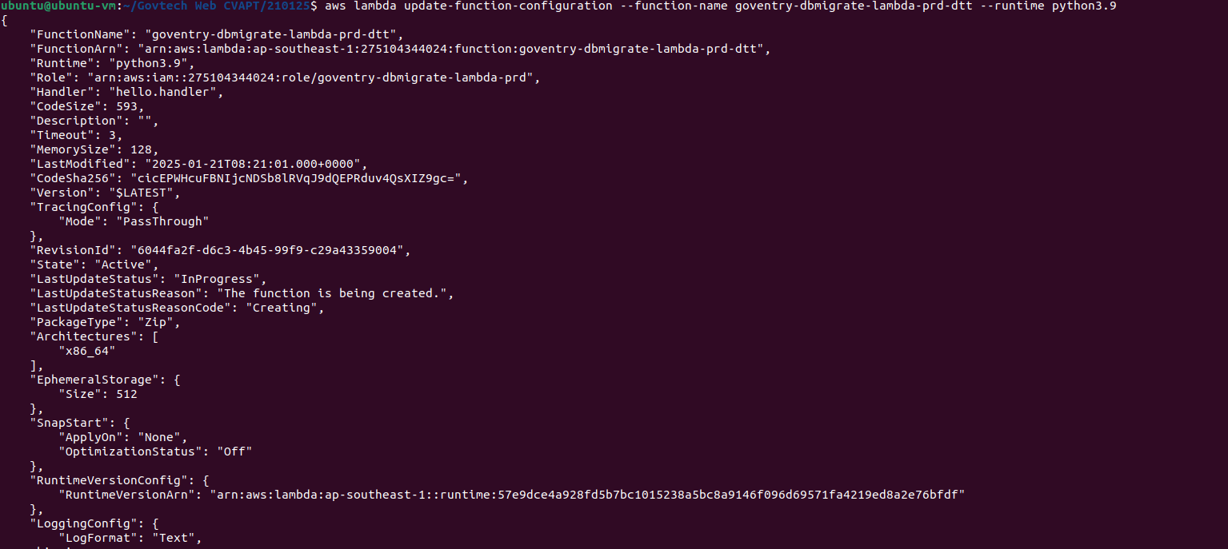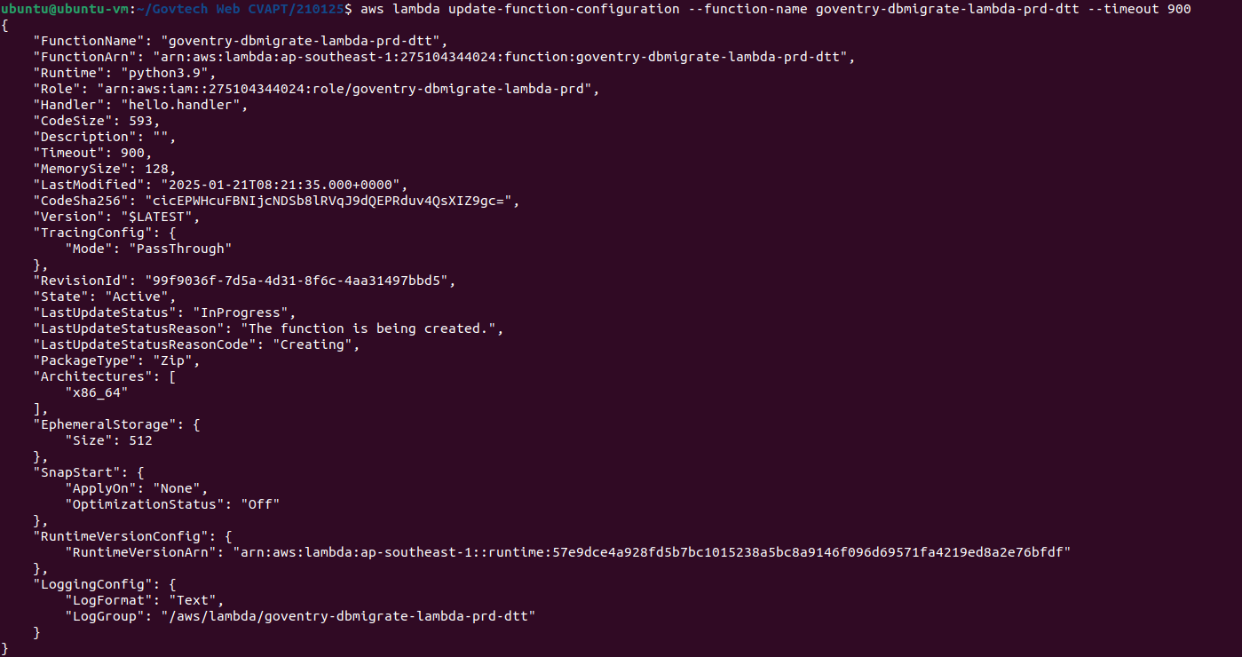
- Upon updating the runtime and timeout of the lambda function, we attempted to modify the code using the “lambda:UpdateFunctionCode” permission to include a python script that creates a new iam role “dtpt-admin-role” and attaches the created unrestricted “dtpt-admin-policy” to it. Without further validation on the uploaded code or signed package requirements, attackers can use this to escalate privileges.
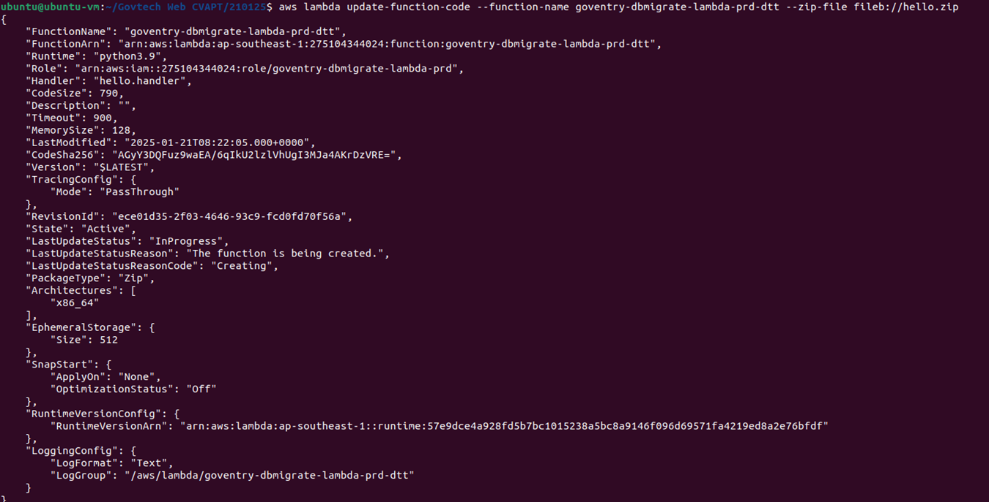
- Upon successfully updating the code, we attempted to invoke the function to execute the injected code. By triggering the execution of the malicious code that creates the administrative role. Without the enforcement of trusted sources for invocation, this step allows the attackers to escalate their privileges by assuming the newly created role. In the code uploaded, we included a statement to output “200” if successful or “500” if unsuccessful.
- Once role creation has been confirmed, leverage the role created by the malicious Lambda function to assume administrative privileges using sts:AssumeRole. The newly created role inherits unrestricted permissions from the “dtpt-admin-policy”, allowing attackers to bypass the original restrictions and perform unauthorized activities.
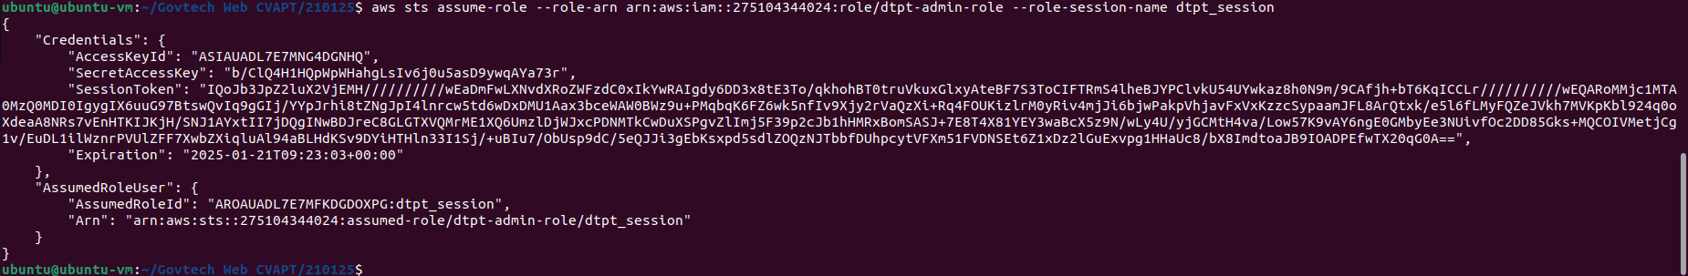
- Assume the newly created role with full administrative permissions and validate the credentials. Additionally, update the maximum session duration to 12 hours, which violates best practices for session management and increases the risk window for misuse.
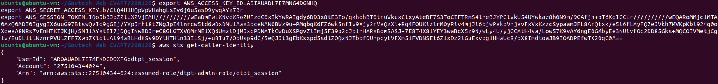
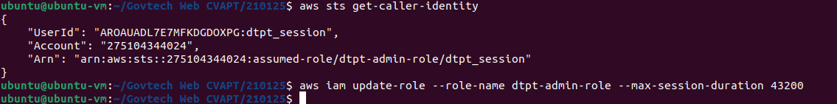
- Created a S3 bucket “test-techpass-dtpt” to demonstrate that an attacker can privilege escalate to gain permission to create and remove S3 buckets.
- Verified that the bucket “test-techpass-dtpt” was created successfully by getting bucket encryption.
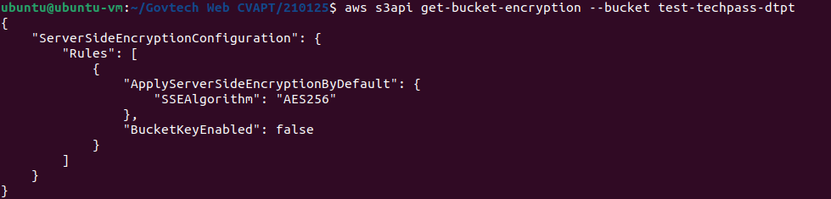
- Delete the “test-techpass-dtpt” bucket created and validate the deletion. Successful deletion might indicate that the resources are vulnerable to availability issues.
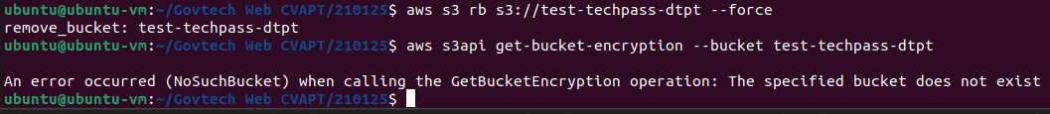

Implications
Attackers may abuse these following permissions to elevate privileges. It is noted that the following highlighted permissions were granted to the identified role:

Permissions | Account ID | Identified Entity
“iam:CreatePolicy*”, “iam:DeleteRolePolicy*”,  “ecs:ListServicesByNamespace*”, “ecs:DiscoverPollEndpoint*”, “ecs:DescribeTaskDefinition*”, “ecs:ListServices*”, “ecs:CreateCapacityProvider*”, “ecs:DeregisterTaskDefinition*”, “ecs:ListAccountSettings*”, “ecs:ListTaskDefinitionFamilies*”, “ecs:RegisterTaskDefinition*”, “ecs:ListTaskDefinitions*”, “ecs:CreateTaskSet*”, “ecs:ListClusters*”, “ecs:TagResource*”, application-“autoscaling:RegisterScalableTarget*”,  “application-autoscaling:DeregisterScalableTarget*”,  "iam:PassRole:  arn:aws:iam::275104344024:role/*  ",  Applicable all resources (*) | 275104344024 | role/sgts-gitlab-runner
“lambda:UpdateFunctionConfiguration”,  “lambda:PublishVersion”, “lambda:UpdateFunctionCode”, “lambda:AddPermission”, “lambda:RemovePermission”, “lambda:DeleteFunctionConcurrency”, “lambda:PutFunctionConcurrency”, “lambda:PutFunctionEventInvokeConfig”, “lambda:DeleteFunctionEventInvokeConfig”, “lambda:UpdateAlias”, “lambda:InvokeFunction”  arn:aws:lambda:ap-southeast-1:275104344024:function:goventry-registration-lambda-prd*, arn:aws:lambda:ap-southeast-1:275104344024:function:goventry-importer-lambda-prd*, arn:aws:lambda:ap-southeast-1:275104344024:function:goventry-esen-exporter-lambda-prd*, arn:aws:lambda:ap-southeast-1:275104344024:function:goventry-dbmigrate-lambda-prd*, arn:aws:lambda:ap-southeast-1:275104344024:function:goventry-stats-lambda-prd*, arn:aws:lambda:ap-southeast-1:275104344024:function:goventry-replymail-lambda-prd* | 275104344024 | role/sgts-gitlab-runner
Recommendations
Understanding that certain permissions such as unrestricted IAM and Lambda privileges may be necessary for specific tasks, the following mitigations can be implemented to reduce the risk of privilege escalation and ensure compliance with least privilege principles:
- Restrict trust policies to specific roles and services with tightly scoped conditions. For example, limit sts:AssumeRole actions by using Condition elements like StringEquals for specific ARNs or tags.
- Regularly review Lambda functions and their associated permissions to ensure they do not have excessive access, particularly to IAM actions like “iam:CreatePolicy”, “iam:PassRole”, and “iam:AttachRolePolicy”.
- Restrict Lambda runtime/code modification permissions (e.g., lambda:UpdateFunctionCode) to isolated roles with logging and approval requirements.
- Regularly review and remove unused or over-permissioned IAM policies, roles, and permissions.
- Enforce a strict policy for role segregation based on job functions and responsibilities, preventing roles from having conflicting permissions that could lead to privilege escalation.
Management Comments
Status
Closed
Follow Up Observations
Based on the implemented restrictions, including the removal of wildcard resource scoping, additional restrictions of affected roles and permissions, and the implementation of code signing for Lambda deployments, the risk associated with this finding has been appropriately mitigated. These measures reduce the attack surface, limit potential privilege escalation, and adheres to the principle of least privilege. the issue can now be closed.

Annex A: Cloud Vulnerability Assessment

